WOLF RANCH
REWILDING NATIVE GRASSLAND PROJECT

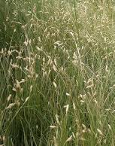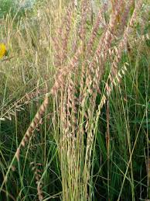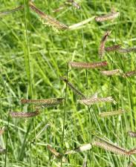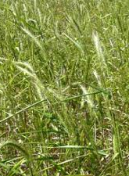
Buffalograss Sideoats Grama Blue Grama Prairie Virginia
Wildrye Wildrye

Texas Grassland is an ecological system dominated by native grasses. This biodiversity of native plant species is adapted to the local climatic conditions. The rewilding project accomplishes the following:

- Re-establishes native prairie grasses that are aesthetically pleasing.
- Provides low maintenance areas with an ecological perspective.
- Reduces resource consumption since species are adapted.
- Restores natural wildlife areas.
- Establishes grasses well-adapted to agronomic conditions.

Enjoy the beauty of these rewilded areas!

